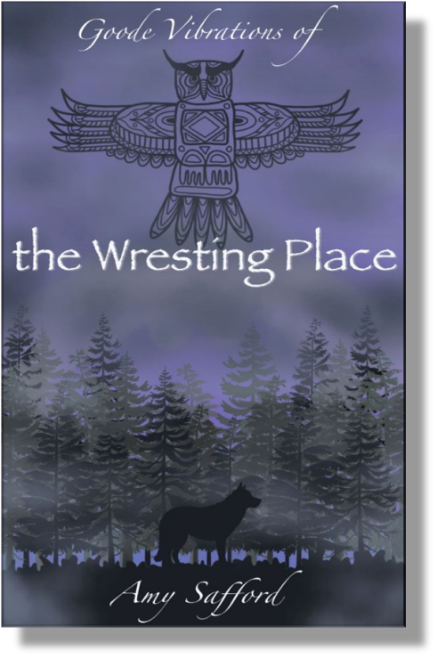
Contact:
Amy Safford 207-423-7029 asafford@saffordcommunications.com
Goode Vibrations – Goode Vibrations of the Wresting Place published by Saco River Books

Debut Novel by Amy Safford Wins
International Literary Awards

SACO, ME, July 1, 2025—For her debut fiction, Goode Vibrations of the Wresting Place, Maine author Amy Safford won the Eric Hoffer 2025 Spiritual Fiction and 2025 First Horizon Awards, along with a silver medal in the 2025 Independent Publishers IPPY Awards for Visionary/New Age Fiction.

Safford was also named a finalist in the American Book Fest 2024 Best Book Awards for Fiction Visionary and the Maine Literary Awards for Speculative Fiction. “I am incredibly honored for the international and state recognition of my debut novel, Goode Vibrations of the Wresting Place. I humbly thank the award judges for reading and appreciating my work and my voice, shining a light on a chapter in our true Maine history,” said Safford.

Part supernatural mystery and part historical fiction, Goode Vibrations of the Wresting Place follows the journey of Penelope “Pennie” Goode who senses her first vibrations while visiting a cemetery where the former settlers of Malaga Island are buried, the remains of the people reinterred on the grounds of the Maine Home for the Feeble Minded in a mass grave. Through a slow process of unearthing her own demons, Pennie uncovers this haunting Maine history and realizes the power of her dreams and visions to fight for justice and the truth.

Amy Safford’s articles and essays have appeared in Soul Magazine, Mythology Journal, Mind Prose and other publications. Goode Vibrations of the Wresting Place is her debut novel and featured on an Authors Radio Podcast. She taught English composition at the University of New England and was a contributing writer to Coastal Fish of Southern Maine and New Hampshire. Her alma maters include Boston University and USM Stonecoast MFA. She lives in Southern Maine.

Goode Vibrations of the Wresting Place is available at Bookshop, Amazon, and other booksellers.
###

